**Setting email on Google app sync**

1. **Go to start > Google Apps Sync > “Set up a google apps Sync user”.**

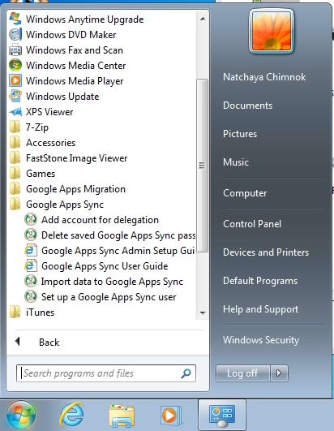

1. **Enter your email address > Continue**

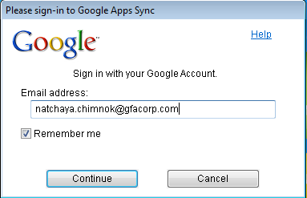

1. **This page will appear > Enter your email address and password > Sign in**

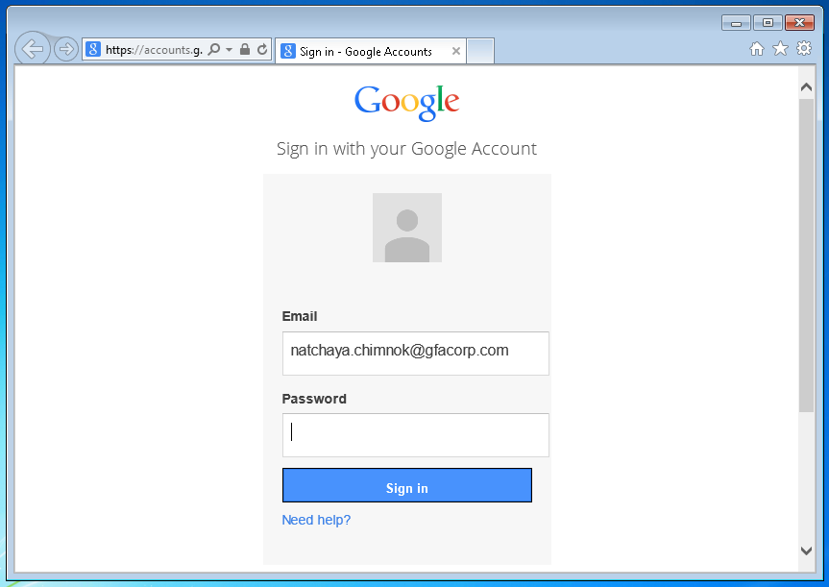

1. **Click Accept/ยอมรับ**

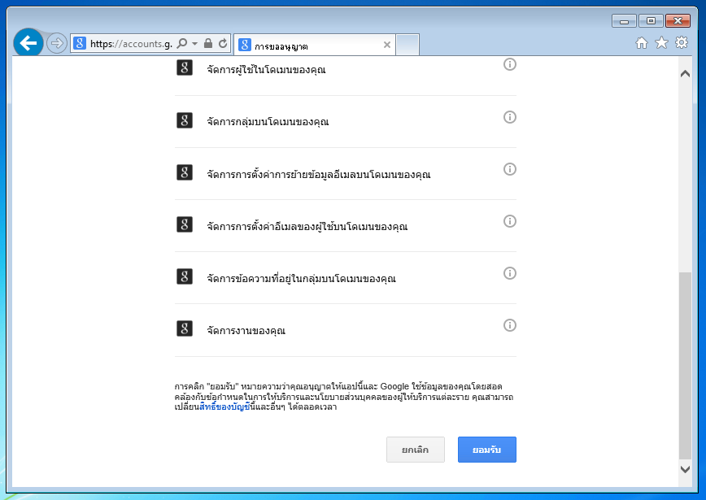

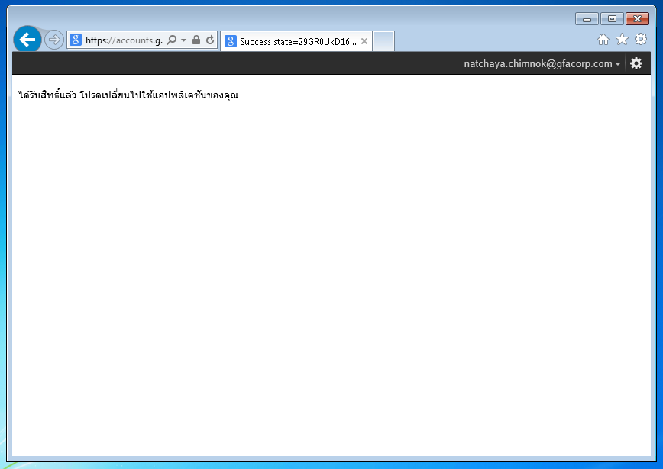

1. **Select “Create profile”**

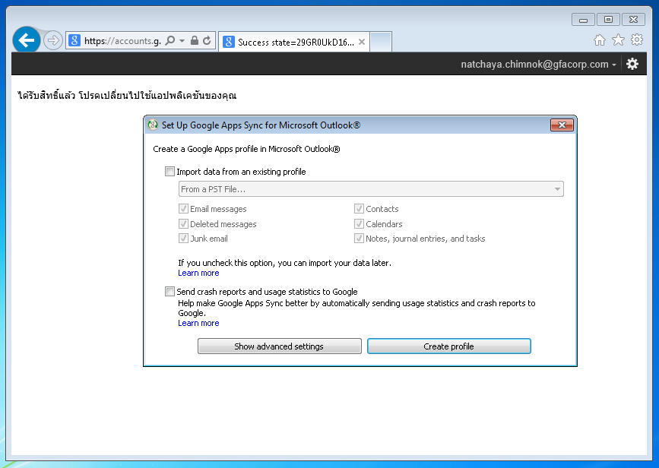

1. **Click on “Start Microsoft Oulook”**

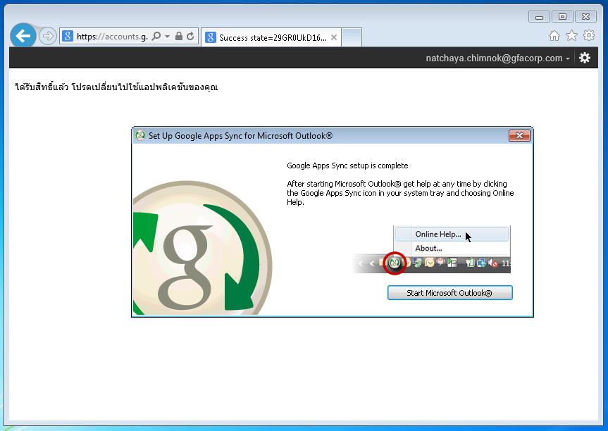

1. **Click “OK”**

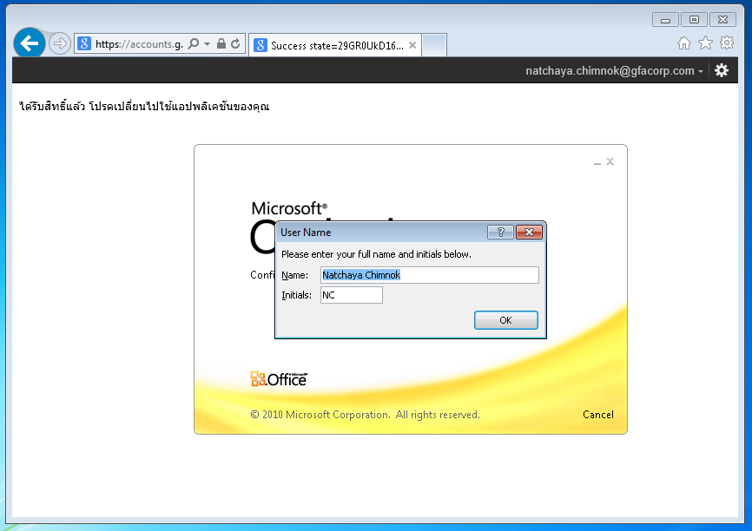

1. **Select “Use Recommended Settings” and click “OK”**
2. **Finish setting outlook via google apps sync program.**

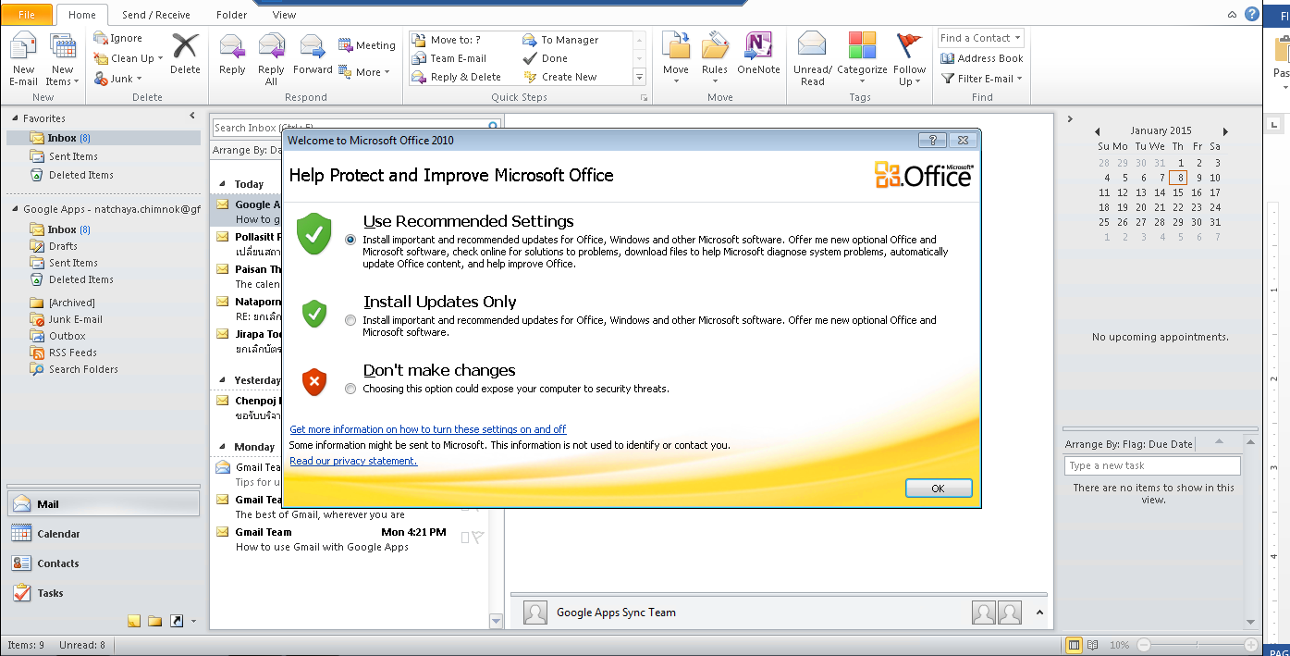

**Add printer on first floor**

**(Fuji Document Centre-IV C2265)**

1. **Go to start > Type “\\dcth01” > Enter**

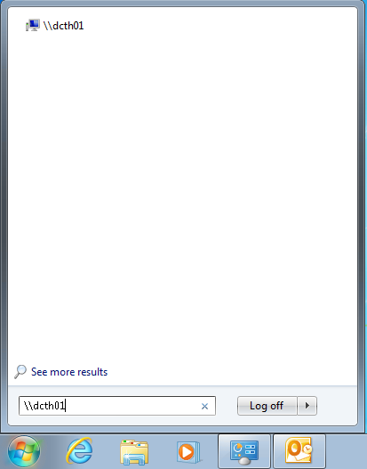

1. **Double click on printer list name “FXDocuCentre-IV C2265 PCL6”**

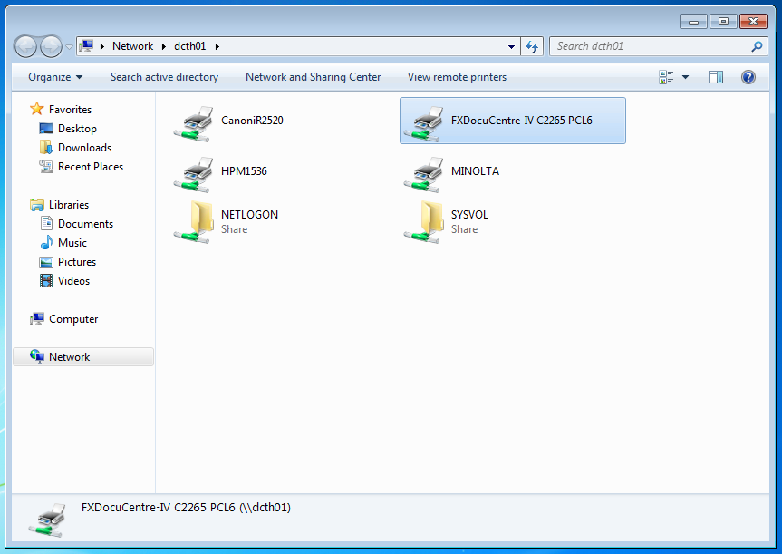

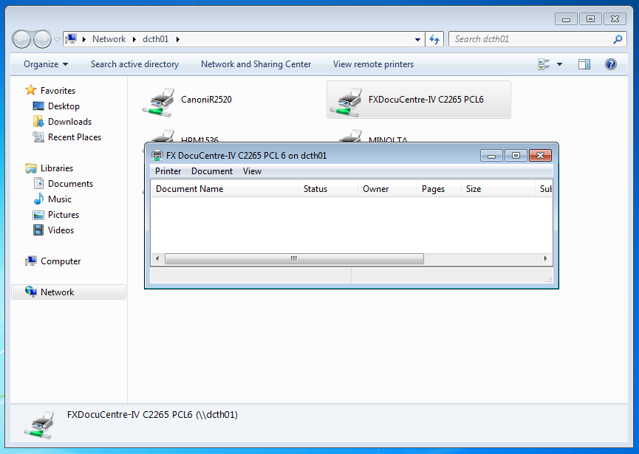

1. **Set printer password by department**
2. **Go to start Device and printers / Control panel > Device and printer**

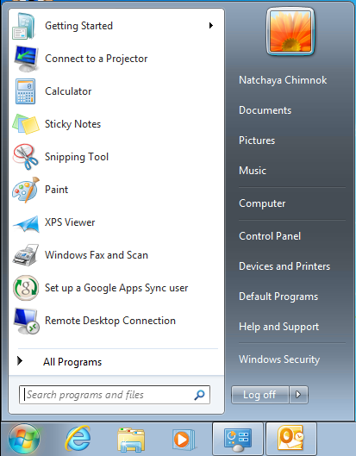

1. **Right click on printer “FX DocuCentre-IV C2265 PCL6” > Printer properties**

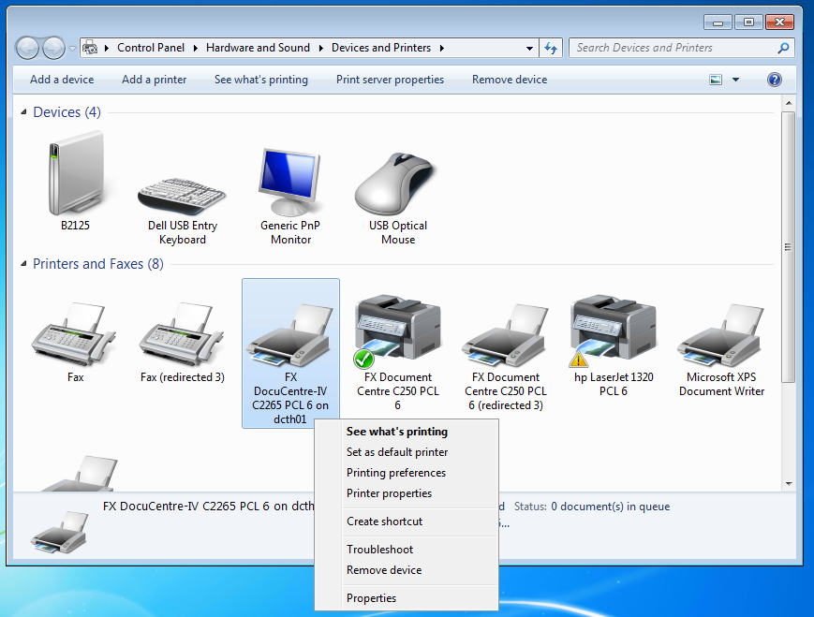

1. **On tab “General” > Preference > Paper/Output**
   1. **Paper size = A4**
   2. **Output color = Black and White**

**Click OK.**

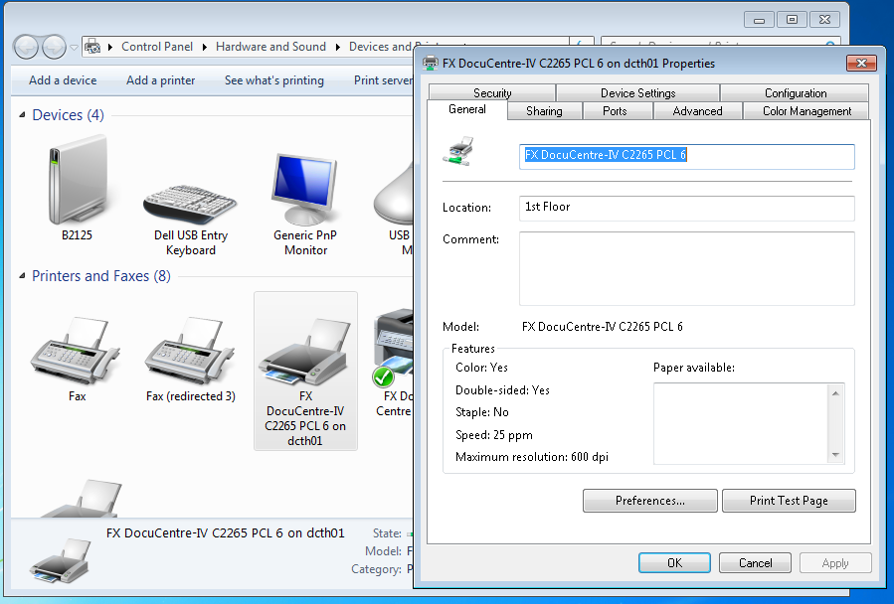

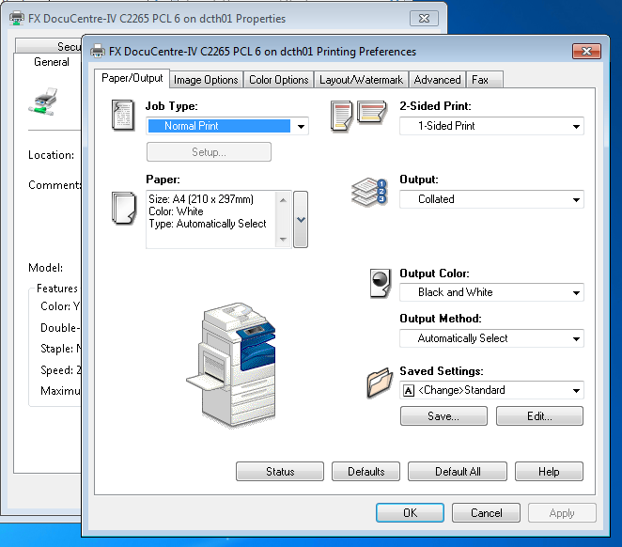

1. **On tab “Configuration” > Accounting…** 
   1. **Select “Always Use Default User Details.**
   2. **Specify job Owner Name=Enter Owner Name**
   3. **User ID= “Password of department”**

**Click OK and finish.**

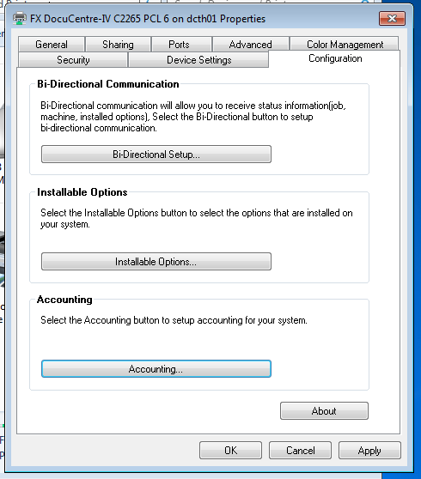 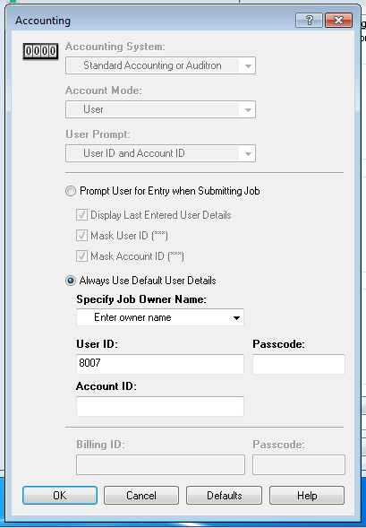

**Change switch language keyboard**

1. **Go to control panel > “Clock, Language and Region” > Regional and language**

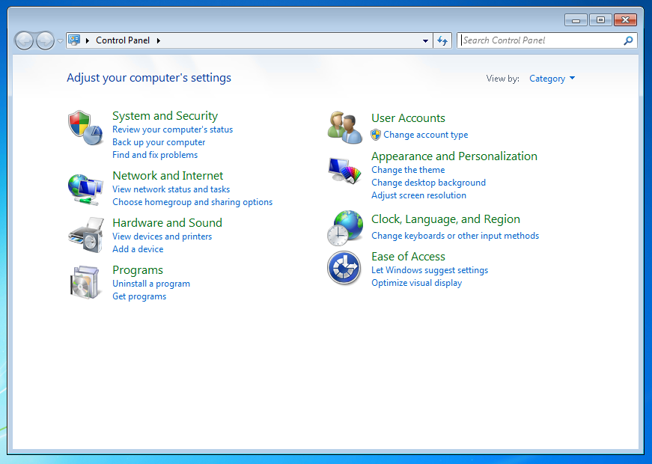

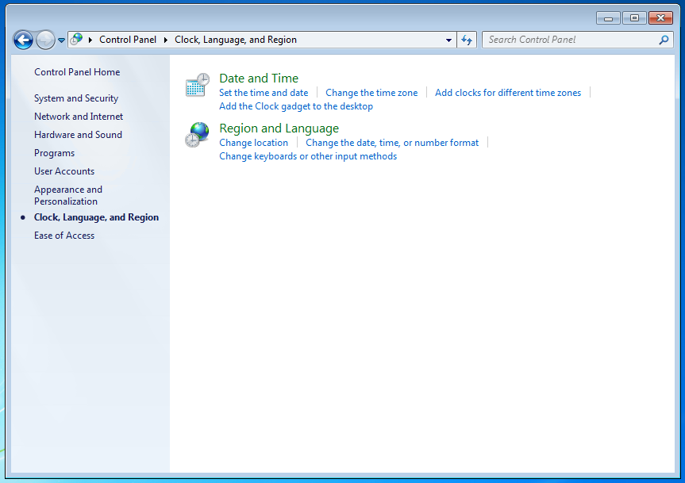

1. **Add THAI language**

**Tab Keyboard and Language > Click “Change Keyboard…” > On Tab “General” > Click “Add” > Select “Thai(Thailand)” > Check on “Thai Kedmanee” > OK**

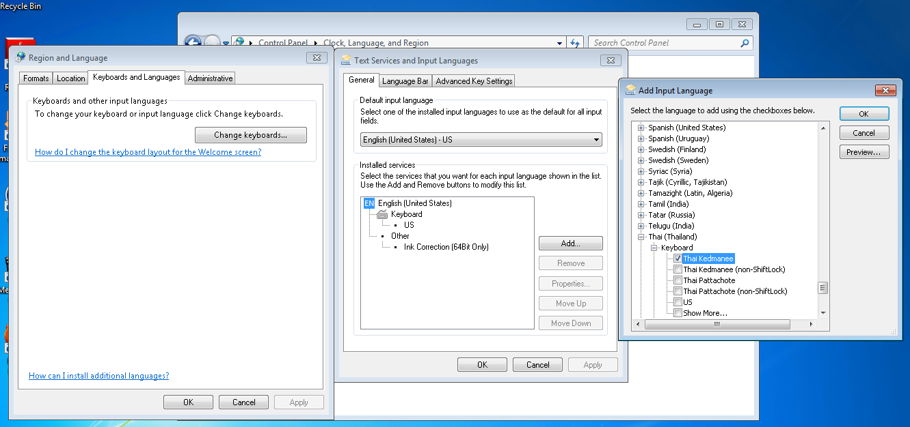

1. **Change way to switch language**

**Tab “Advanced Key Settings” > Select “Between input languages” > “Change Key Sequence…” > “Grave Account” > OK**

